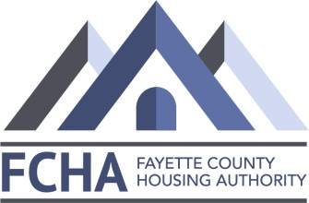
Fayette County Housing Authority
624 Pittsburgh Road Phone: 724-434-2100
Uniontown, PA 15401 www.faycha.org

NOTICE
Mark Yauger
Executive Director

Board of Directors

Harry Fike
Chairman

Ernest DeBlasio
Vice-Chairman

Joyce Nuccetelli
Treasurer

Kerri Baker
Asst. Treasurer

Beverly Beal
Secretary

Davis & Davis
Attorneys at Law

The Fayette County Housing Authority is currently purging its Section 8 Waiting List. If you have applied for Section 8 Housing in 2017 or 2018, you either have already been contacted or will be contacted regarding your interest in the Program.

If you receive a letter from the Housing Authority, you need to open it immediately, as there will be a deadline date for you to respond as to your interest in the Program. If you do not meet the deadline, your Section 8 Application will automatically be withdrawn, and if you are still interested in Section 8 Housing, you will have to re-apply and go back on the Waiting List, which, at this time, is approximately a 2 year wait. There will be no exceptions to the deadline date.

The Housing Authority intends to issue Vouchers to all interested applicants who return their information prior to the deadline, and meet all the requirement of the Department of Housing and Urban Development (HUD).

If you have any questions, please call the Tenant Selection Department of the Fayette County Housing Authority at 724-434-2118.

